
Spiritual
Adoption
What is the Spiritual Adoption Program?
It is very simple. Participants in the Spiritual Adoption Program pledge to pray for nine months for an unborn baby. While this child will remain unknown to his or her 'spiritual parent', God knows who the child is. Many people have found that naming 'their child' helps to keep them focused on the reality that their prayers are helping to keep a particular baby safe.
What are the objectives of the Spiritual Adoption Program?
1. Encourage prayer for parents who are expecting a child, that they will respond to God's grace and welcome their child into life.
2. Educate adults and children about the development of the preborn child.
3. To collaborate with efforts of “Walking With Moms in Need” by concluding the program by holding a “baby shower” or “birthday party” where gifts are donated to help expectant mothers from the parish or at a pregnancy center.
Who can participate?
Anyone who is concerned about the unborn, and who is willing to pray!
Schools, religious education programs, or the entire parish.
"…that they might have life and have it to the full." (John 10:10)
“Before I formed you in the womb, I knew you.” Jeremiah 1:5

Choose a Group: Decide whether you want to initiate this program within your school, parish, or family. Determine the age groups you'll be working with, as this will help you tailor the materials and activities accordingly.
Decide what materials you need: Typical would be a combination of posters, prayer cards, brochures, and/or pledge cards.
  - http://www.littleonepublishing.com/ - posters and brochures
  - https://www.hearts4life.org/ - prayer/pledge cards
  - http://www.spiritualadoption.org/ - more info and cards
  - https://www.4life4family.org/spiritual-adoption-schools/ - ideas
Spiritual Adoption in Action
https://catholicherald.org/local/sacred-heart-launches-spiritual-adoption-campaign/
https://www.stkdsfsd.org/spiritual-adoption-program

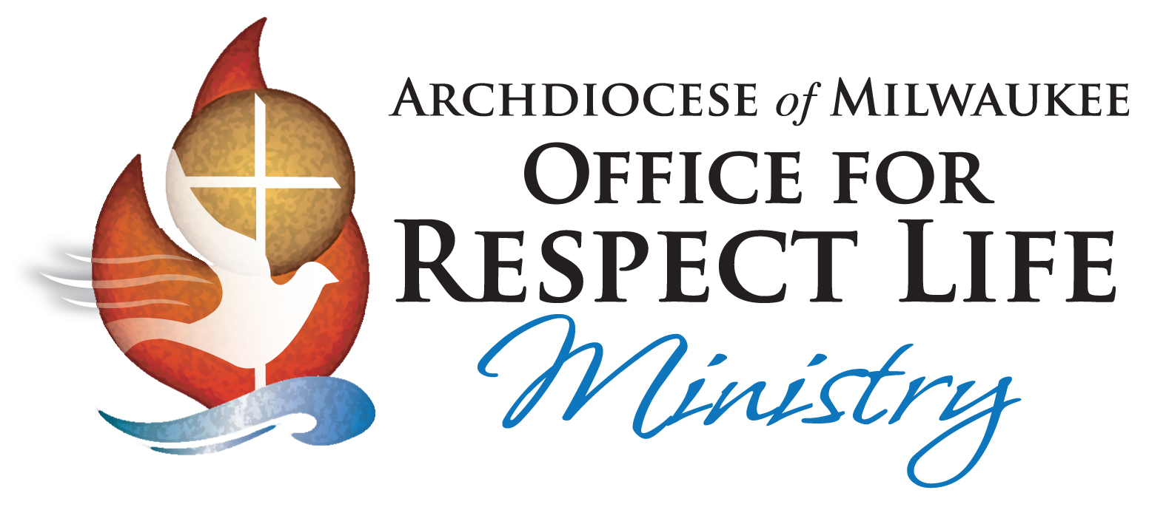
For more help, ideas, and to order free prayer cards, please call …
Deacon Jim Matthias at 414-769-3454.

Archdiocese of Milwaukee | Respect Life Office
3501 S. Lake Drive | St. Francis, WI 53235
matthiasj@archmil.org

How do I get started?
Start by talking to your parish Respect Life Committee, Human Concerns, and/or your pastor. Discuss the purpose of the Spiritual Adoption Program.
Step 1: Setting the Dates Decide on the duration of the program, such as starting in a specific month and ending after nine months. You've provided options like beginning in January and ending in October (Respect Life month) or starting in August and ending in May (on Mother’s Day).
Step 2: Initial Announcement About two weeks before the program starts, place an announcement in the parish bulletin inviting parishioners to participate. This announcement could provide a brief overview of the program's purpose and how it works.
Step 3: Continued Promotion One week before the program begins, make verbal announcements during Mass services to remind parishioners about the upcoming program. Encourage them to read the bulletin for further details. Republish the written announcement from the previous week's bulletin.
Make prayer/pledge cards available either in the bulletin or at designated places within the church. These cards could be printed on pink and blue paper to symbolize the gender of the unborn child.
Step 4: Program Launch On the week the program starts, encourage parishioners to place their completed pledge cards in a designated container placed near an appropriate location, such as the Blessed Mother Shrine. Alternatively, they can bring the pledge cards up during the Offertory and place them near the altar. Ensure that additional pledge cards and writing instruments are available at the end of each pew for those who forget to bring their cards.
Step 5: Thank You Note Around two weeks after the program begins, express gratitude to those who have already participated. Publish a thank-you note in the bulletin and share the number of individuals and families participating. Make sure pledge cards and a collection container remain available for latecomers who wish to pledge.
Step 6: Monthly Updates Each month, prominently display development posters that depict the stages of fetal development. Include these posters where they can be easily seen by everyone. Additionally, provide monthly bulletin announcements as reminders for parishioners to continue praying for their spiritually adopted child. Include information on the development of unborn children to maintain engagement and awareness.
Step 7: Program Conclusion Celebration At the end of the program, plan a celebratory event for all participants. This could be a simple social gathering, a baby shower, or another form of celebration. You can also use this occasion to collect new baby items or monetary gifts to be donated to maternity homes or pregnancy centers that support alternatives to abortion.

